**Dynamic Simulation of ASV Cluster Adaptively Navigating in a 2D Vector Field**

Members: Ryan Cooper, Garren Hendricks, Danop Rajabhandharaks

We created a simulation that can reproduce the previous vector field work while simulating the dynamics of a 3 ASV cluster modeled after the differential drive kayaks used in the lab. We have made a controller that goes to a specific response in the vector field and holds there, which we have called travelling along the vector contour of that specific response value, either a vector magnitude or direction, or both. This is similar to contour following in scalar fields. We have created a controller travels up the trench created by two sources or two sinks.

We demonstrated these achievements by displaying a plot of the cluster as it travels in the vector field toward its goal states for each scenario that we have. This includes finding a source, sink, vortex, and doublet using the two previous techniques that have been done before, following the “contour” of a source, sink, doublet, and vortex, and following a trench created by two sources or two sinks.

Our simulation is capable of working during a singularity formation of the cluster. It also makes cool plots!

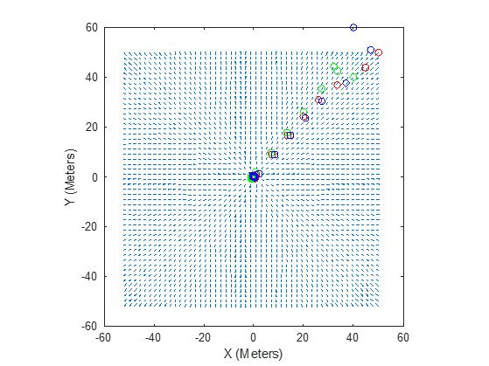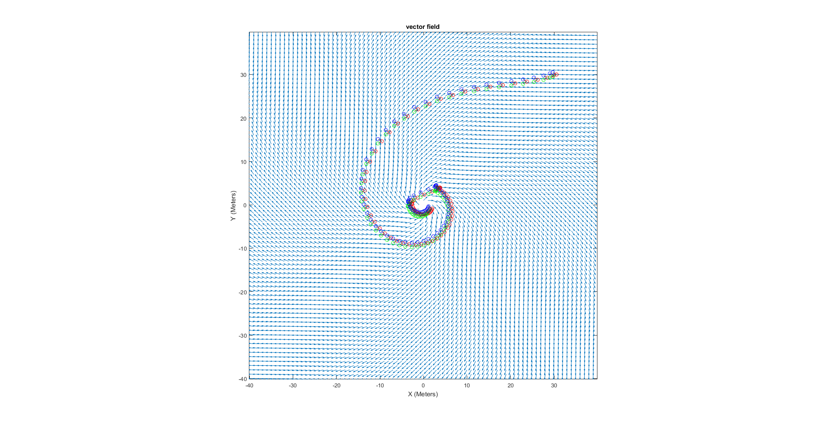

The graph on the left shows the cluster navigating to a source located at [0,0]. The graph on the right shows the cluster navigating to the center of a vortex located at [0,0] by following the direction of the field.

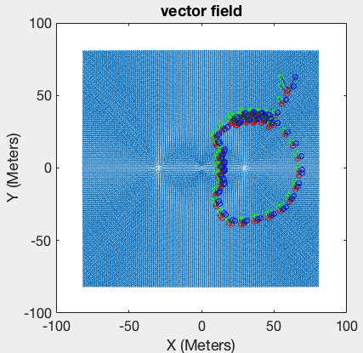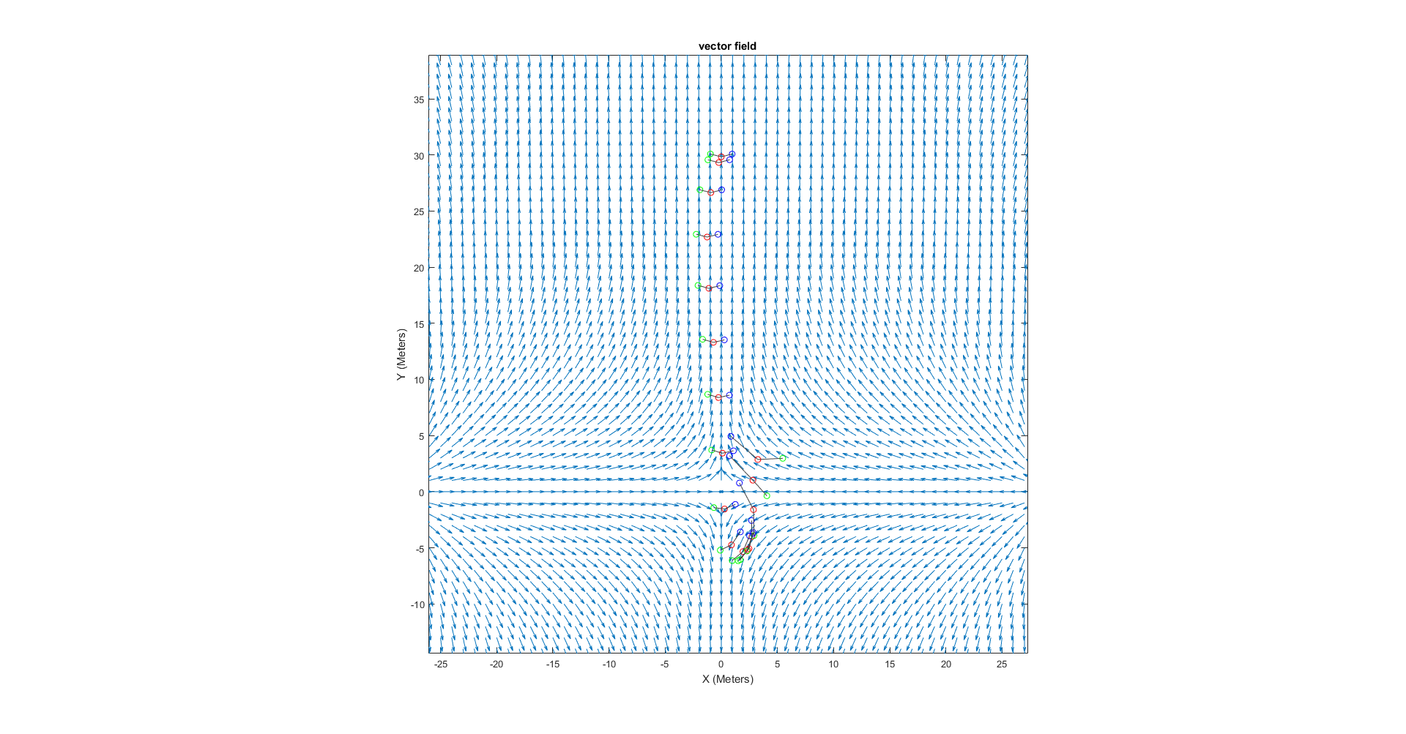

The graph on the left shows the cluster following a contour level of 0.6 in a field with two sources located at [+-20, 0]. The graph on the right shows the cluster stays on a trench and descends to the stagnation point at the center.